Table of Contents

List of figures iii

1 Introduction and Background 1

1.1 INTRODUCTION 1

1.2 PROBLEM DEFINITION 2

1.2.1 What is the importance of this problem? 2

1.2.2 What are the current solutions? 2

1.2.3 How will our solution solve the problem? What is new? 3

1.3 SCOPE 4

2 Analysis and Design 5

2.1 INTRODUCTION 5

2.2 USER AND SYSTEM REQUIREMENTS 5

2.2.1 User Requirements 5

2.2.2 Functional Requirements 5

2.2.3 Non-functional Requirements 6

2.3 STACKHOLDERS 7

2.3.1 Supervisor 7

2.3.2 AI System 7

2.4 SYSTEM DESIGN 7

2.4.1 Gantt Chart 7

2.4.2 Use Case Diagram 8

2.4.3 Activity Diagrams 9

2.4.4 Class Diagram 12

2.4.5 Sequence Diagrams 12

2.4.6 State Diagrams 14

2.4.7 Data Flow Diagrams 17

2.5 USED TECHNOLOGIES AND TOOLS 18

2.5.1 Hardware 18

2.5.2 Software 19

2.6 SUMMARY 19

3 IMPLEMENTATION AND EVALUATION 20

3.1 INTRODUCTION 20

3.2 DATASETS 20

3.3 PREPROCESSING DATA 20

3.3.1 Resize and Normalization 21

3.3.2 Data Augmentation 22

3.3.3 Pose Estimation Using Open Pose 23

3.3.4 Using YOLOv3 Pre-Trained Model 26

3.4 Modeling 27

3.4.1 Custom CNN Model 27

3.4.2 CONV1d + SVM 31

3.4.3 VGG-16 Model 34

3.4.4 MobileNet and ResNet 37

3.5 TESTING AND EVALUATION 40

3.6 SUMMARY 43

4 DISCUSSION AND CONCLUSION 45

4.1 INTRODUCTION 45

4.2 MAIN FINDINGS 45

4.2.1 Why Is This Project Important 45

4.2.2 Practical Implementations 46

4.3 LIMITATIONS 46

4.4 FUTURE RECOMMENDATION 46

4.5 SUMMARY 47

5 References 48

# **Introduction**

In a world where effective communication is paramount, the Sign Language Translator project stands as a pioneering effort to bridge the communication gap for the deaf community.

This initiative aims to provide an accessible and user-friendly solution for seamless communication between individuals with hearing impairments and the broader society. Whether manifested as a mobile application or a web page, the potential application relies on cutting-edge artificial intelligence technology to convert textual inputs into sign language.

Distinguished by an AI-driven model, the project excels in analyzing textual inputs with precision, translating them into sign language accurately and efficiently. Additionally, the application grants access to the camera, allowing the conversion of sign language into text, thereby opening new avenues for interaction with the surrounding environment.

The interface is designed to be simple and intuitive, ensuring user-friendly navigation, with customizable settings to cater to individual needs.

The project endeavors to enhance communication for the deaf community, fostering a sense of inclusivity and contributing to an improved quality of daily life. Join us on this transformative journey as we strive to make communication a universal right for everyone, transcending barriers and fostering a more connected and inclusive world.

# Problem Definition:

## 1. Description of the Problem:

* *The project aims to develop a Sign Language Translation that facilitates communication between individuals who use sign language and those who do not. The goal is to bridge the communication gap and provide a seamless means for sign language users to interact with the broader community.*

## 2. Scope of the Problem:

* *The scope includes the development of a real-time sign language translation system that can interpret and convert sign language gestures into spoken or written language.*

3. Objectives and Goals:

* *a. Enable effective communication for individuals who are deaf or hard of hearing in various settings, including educational institutions, workplaces, and social environments.*
* *b. Develop a user-friendly interface that accommodates both sign language users and those unfamiliar with sign language.*
* *c. Provide accurate and timely translation of sign language gestures to spoken or written language.*

4. Constraints and Limitations:

* *a. The system must operate in real-time to ensure effective and natural communication.*
* *b. Consideration for different dialects and variations within the chosen sign language.*
* *c. Accessibility requirements, ensuring the system is usable by individuals with varying levels of technological proficiency.*

5. Stakeholders and Users:

* *a. Primary stakeholders include individuals who are deaf or hard of hearing.*
* *b. Secondary stakeholders include educators, employers, and community members interested in fostering inclusive communication*.

6. Functional Requirements:

* *a. Capture and interpret sign language gestures through computer vision or similar technology.*
* *b. Translate interpreted gestures into spoken language or text.*
* *c. Provide a user interface that is intuitive for both sign language users and non-sign language users.*

7. Non-functional Requirements:

* *a. Ensure high accuracy in gesture recognition to minimize misinterpretations.*
* *b. Minimize latency to achieve real-time communication.*
* *c. Implement security measures to protect user privacy and data.*

8. Assumptions and Risks:

* *a. Assumption: Adequate training data for the chosen sign language will be available.*
* *b. Risk: Variability in individual signing styles may pose challenges for accurate interpretation*.

9. Success Criteria:

* *a. Achieve a recognition accuracy rate of at least 95% in real-world scenarios.*
* *b. Positive feedback from end-users regarding the system's usability and effectiveness.*

# Problem Solution:

1. Proposed Solution:

* *Develop a Sign Language Translation that employs a combination of computer vision, machine learning, and natural language processing techniques to accurately interpret sign language gestures in real-time. The system will then translate these gestures into spoken language or text, providing a seamless means of communication for individuals who use sign language.*

2. Technical Approach:

* *a. Computer Vision: Utilize computer vision algorithms to capture and analyze sign language gestures through video input.*
* *b. Machine Learning: Implement machine learning models trained on diverse datasets to enhance the system's accuracy and adaptability to individual signing styles.*
* *c. Natural Language Processing: Employ natural language processing algorithms to convert interpreted gestures into spoken language or written text.*

3. System Architecture:

* *a. The system will consist of a camera or sensor to capture sign language gestures.*
* *b. Computer vision algorithms will preprocess and interpret the gestures.*
* *c. Machine learning models will refine the interpretation based on individual user patterns.*
* *d. The translated output will be presented through a user-friendly interface, including spoken language output and/or on-screen text.*

4. User Interface Design:

* *a. Develop an intuitive interface that accommodates both sign language users and non-sign language users.*
* *b. Include visual feedback to confirm the system's understanding of gestures.*
* *c. Provide options for customization, allowing users to adapt the system to their individual preferences.*

5. Testing and Validation:

* *a. Conduct rigorous testing using diverse datasets to train and evaluate the machine learning models.*
* *b. Perform user testing with individuals who use sign language to validate the system's accuracy and usability.*
* *c. Iterate on the system based on user feedback to continuously improve performance.*

6. Accessibility and Inclusivity:

* *a. Ensure the system is accessible to individuals with varying levels of technological proficiency.*
* *b. Implement features that consider different dialects and variations within the chosen sign language.*
* *c. Prioritize user privacy and data security in the design and implementation.*

7. Deployment and Scalability:

* *a. Develop the system with scalability in mind to accommodate potential expansion to other sign languages.*
* *b. Plan for easy deployment in diverse settings, including educational institutions, workplaces, and community spaces.*

8. Monitoring and Maintenance:

* *a. Implement monitoring tools to track system performance and user feedback.*
* *b. Establish a maintenance plan to address issues, update models, and incorporate improvements over time.*

9. Expected Outcomes:

* *a. Achieve a recognition accuracy rate of at least 95% in real-world scenarios.*
* *b. Positive feedback from end-users regarding the system's usability and effectiveness.*

*c. Increased accessibility and inclusivity in communication for individuals who use sign language.*

# **Scope**

1. Objective:

- Develop an advanced Sign Language Translator application that enables seamless communication between individuals with hearing impairments and the broader community.

- Provide a user-friendly interface for text-to-sign language and sign language-to-text translations, supporting inclusivity and accessibility.

2. Location:

- The project will be designed as a mobile application and a web page, ensuring accessibility across various devices and platforms.

3. Budget:

- Allocate resources for the development, testing, and implementation phases.

- Account for potential expenses related to AI model development, server hosting, and platform compatibility.

4. Milestones:

- Define key milestones, including the completion of AI model development, implementation of translation features, user interface design, testing phases, and the launch of the application.

5. Main Stakeholders:

- Deaf and hard-of-hearing individuals.

- Developers and project management team.

- Potential investors or funding sources.

- User experience and accessibility experts.

6. Projects Parts/Components:

- Text-to-Sign Language Translation Module.

- Sign Language-to-Text Translation Module.

- User Interface Design.

- Camera Integration Module.

- Cross-Platform Compatibility Module.

- Security and Privacy Features.

- Testing and Quality Assurance.

7. Project Description:

- The project aims to create a state-of-the-art Sign Language Translator application, leveraging AI for accurate translation between text and sign language. The user-friendly interface and camera integration facilitate dynamic and inclusive communication.

8. Type of Works (BOQ - Bill of Quantities):

- Specify the quantity and types of resources needed for AI model development, server hosting, software development, and testing.

9. Roles and Responsibilities for Different Parties:

- Developers: Responsible for AI model development, software coding, and application testing.

- Project Management Team: Oversee project timelines, milestones, and resource allocation.

- User Experience Experts: Ensure the design meets accessibility standards and provides an optimal user experience.

- Investors/Funding Sources: Provide financial support for the project.

- Testing Team: Conduct thorough testing to identify and resolve any issues before the application launch.

By addressing these components within the project scope, you establish a comprehensive framework that guides the development and implementation of the Sign Language Translator application.

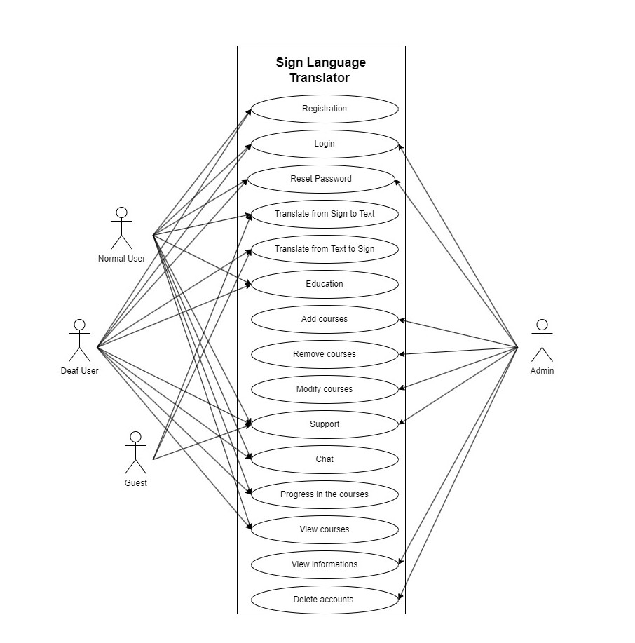

|  |  |
| --- | --- |
| Use Case ID | 1 |
| Use Case name | Registration |
| Actors | Normal user, Deaf user. |
| Preconditions | None. |
| Normal Flow | 1. User clicks on Sing Up button. 2. User fills in his/her information. 3. User receive confirmation E-mail 4. The system displays the Sign Translation page. |
| Post conditions | 1. Open translation page 2. The user’s details are stored in the database. |
| Alternative Flow | The information already exists. |

|  |  |
| --- | --- |
| Use Case ID | 2 |
| Use Case name | Login |
| Actors | Admin, Normal User, Deaf User. |
| Preconditions | Admin, Normal User and Deaf User Must do Registration. |
| Normal Flow | 1.Insert Username.  2.Insert Password.  3.Login. |
| Post conditions | Login Successfully. |
| Alternative Flow | 1.Insert the Incorrect Username.  2.Insert the Incorrect Password. |

|  |  |
| --- | --- |
| Use Case ID | 3 |
| Use Case name | Reset Password |
| Actors | Admin, Normal User, Deaf User. |
| Preconditions | Admin, Normal User and Deaf User Must do Registration. |
| Normal Flow | 1.Insert Username.  2.Insert Email Address.  4.Change Password.  5.Password Reset. |
| Post conditions | Password has been Reset. |
| Alternative Flow | 1.Insert the Incorrect Username.  2.Insert the Incorrect Email Address.  3.Insert the Same Old Password. |

|  |  |
| --- | --- |
| Use Case ID | 4 |
| Use Case name | Translate From Sign to Text |
| Actors | Normal User, Guest |
| Preconditions | Normal User or Guest must enter the sign which he wants to translate to text |
| Normal Flow | 1. Enter the sign you want to translate to text 2. Translate |
| Post conditions | Translate from sign to text successful |
| Alternative Flow | * did not enter any sign or enter a sign that not understood |

|  |  |
| --- | --- |
| Use Case ID | 5 |
| Use Case name | Translate From Text to Sign |
| Actors | Deaf User, Guest |
| Preconditions | The Deaf User or the Guest must enter the text which he wants to translate to sign |
| Normal Flow | 1. Enter the text you want to translate to sign 2. Translate |
| Post conditions | Translate from text to sign successful |
| Alternative Flow | * did not enter any text or enter a not understood text |

|  |  |
| --- | --- |
| Use Case ID | 6 |
| Use Case name | Education |
| Actors | Normal user, Deaf user |
| Preconditions | Users have access to the educational platform.  Course content is available for the selected course. |
| Normal Flow | 1. User logs into the educational platform.  2. User selects a course.  3. User views course content and interacts with it.  4. Deaf user may require accessible content (sign language videos or transcripts). |
| Post conditions | The user successfully accesses and interacts with the course content.  Deaf user receives accessible content if needed. |
| Alternative Flow | In case of technical issues, the user is redirected to a support page.  Deaf user may require alternative content if accessible content is not available. |

|  |  |
| --- | --- |
| Use Case ID | 7 |
| Use Case name | Add Course |
| Actors | Admin |
| Preconditions | Admin has access to the course management system. |
| Normal Flow | 1. Admin logs into the course management system.  2. Admin navigates to the "Add Course" section.  3. Admin provides course details.  4. Admin click on “Add Course” button.  5. The system verifies and stores the course information. |
| Post conditions | The new course has been successfully added to the system. |
| Alternative Flow | If there are any validation errors (missing information or duplicate course name), the system prompts the admin to correct the errors and resubmit. |

|  |  |
| --- | --- |
| Use Case ID | 8 |
| Use Case name | Remove courses |
| Actors | admin |
| Preconditions | The admin must enter the course code to remove it |
| Normal Flow | 1- Admin login.  2-Admin click on delete course tap  3- Confirm the admin identity  4-Admin enter course code  5-Admin click on delete button |
| Post conditions | Course deletes successful |
| Alternative Flow | have not entered the course code or entered the course code incorrectly |

|  |  |
| --- | --- |
| Use Case ID | 9 |
| Use Case name | Modify courses |
| Actors | admin |
| Preconditions | The admin must enter the course code to modify it |
| Normal Flow | 1- Admin login.  2-Admin click on modify course tap  3- Confirm the admin identity  4-Admin enter course code  5-Admin click on modify button |
| Post conditions | Courses modify successful |
| Alternative Flow | have not entered the course code or entered the course code incorrectly |

|  |  |
| --- | --- |
| Use Case ID | 10 |
| Use Case name | Technical Support |
| Actors | Normal User, Deaf User, Guest, Admin. |
| Preconditions | Normal User, Deaf User and Guest request support. |
| Normal Flow | 1. Request support. 2. Wait for answers. |
| Post conditions | Manage Support Requests. |
| Alternative Flow | -If there are technical issues with the request submission:  1-The system displays an error message.  2-The user is instructed to try again later. |

|  |  |
| --- | --- |
| Use Case ID | 11 |
| Use Case name | Chat |
| Actors | Normal User, Deaf User, Guest. |
| Preconditions | Normal User, Deaf User and Guest must do registration. |
| Normal Flow | 1. Login 2. Go to chat section or Search for any account. 3. Start chat |
| Post conditions | Message sent successfully. |
| Alternative Flow | 1-Insert incorrect username.  2-Insert incorrect password.  3-Faild to send message. |

|  |  |
| --- | --- |
| Use Case ID | 12 |
| Use Case name | progress in courses |
| Actors | Normal user, deaf user |
| Preconditions | View courses and learn through them in the system |
| Normal Flow | 1. view courses 2. learning 3. show progress in courses |
| Post conditions | Log out (optional) |
| Alternative Flow | no courses added by admin |

|  |  |
| --- | --- |
| Use Case ID | 13 |
| Use Case name | View courses |
| Actors | Normal user, deaf user |
| Preconditions | Normal User and Deaf User Must do Registration and log in successfully  Admin must add course  Normal User, Deaf User must progress in courses |
| Normal Flow | view courses |
| Post conditions | Access the courses Learning from them |
| Alternative Flow | no courses exist |

|  |  |
| --- | --- |
| Use Case ID | 14 |
| Use Case name | View Information |
| Actors | Admin |
| Preconditions | User Must be Logged in As Admin |
| Normal Flow | 1. Admin login. 2. Click on View profiles button. 3. Search for the profile he wants to view 4. Display User profile |
| Post conditions | View user profile |
| Alternative Flow | The user does not exist |

|  |  |
| --- | --- |
| Use Case ID | 15 |
| Use Case name | Delete Accounts |
| Actors | Admin, Normal User, Deaf User |
| Preconditions | User must be logged in |
| Normal Flow | 1. Click on view profile button. 2. Click on delete account button. 3. Confirm deleting account by entering account password |
| Post conditions | Account deleted successfully |
| Alternative Flow | Account password is incorrect |

**Activity Diagrams:**

1. **Registration:**

1. **Login:**

1. **Reset Password:**

1. **Translate from sign to text:**

1. **Translate from text to sign:**

1. **Education:**

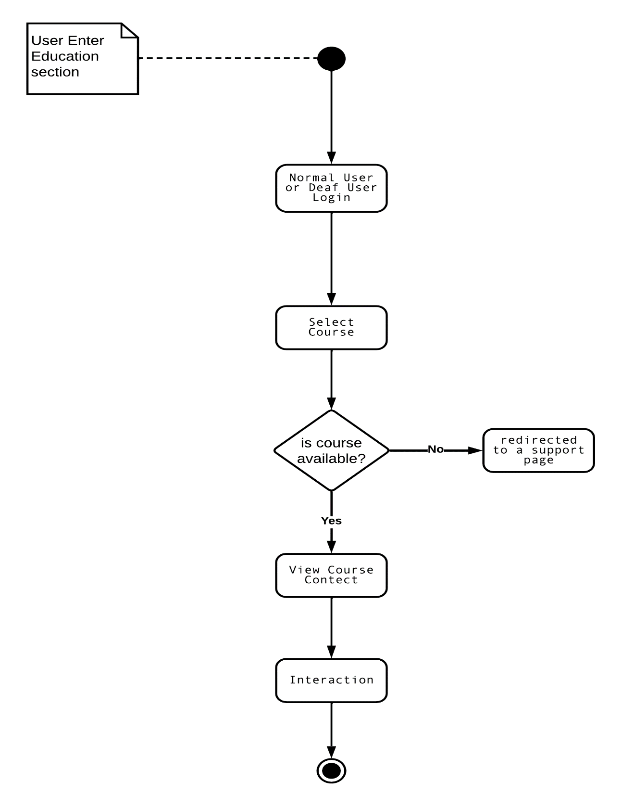

1. **Add Course:**

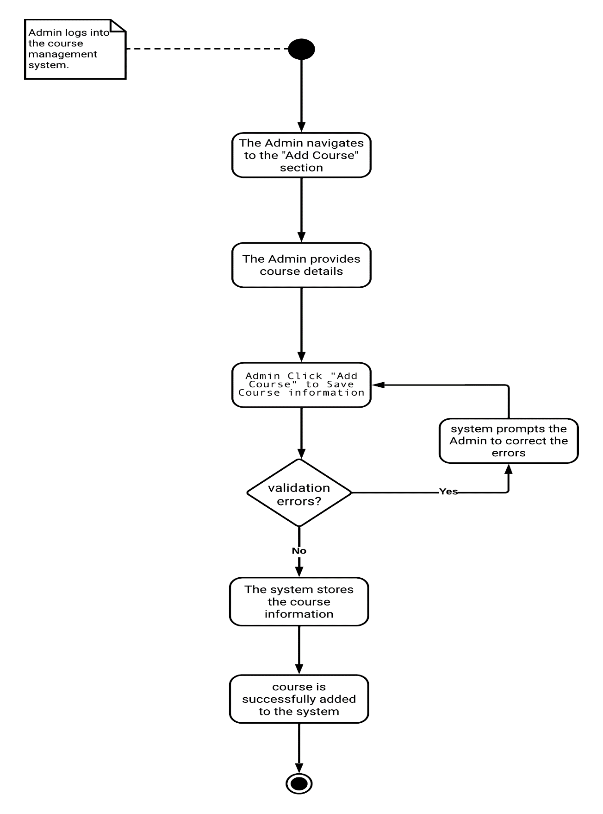

1. **Remove courses**

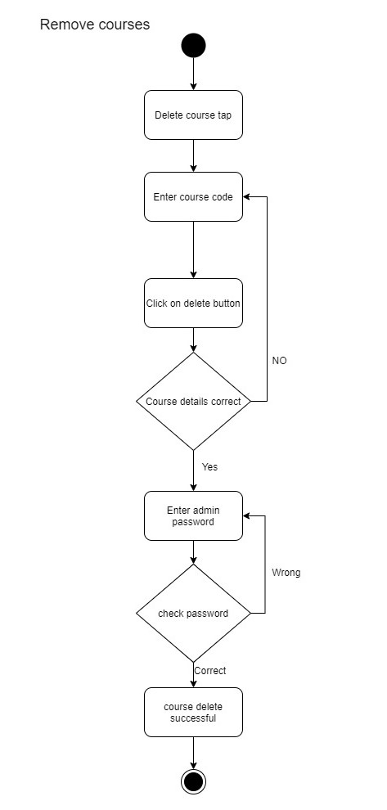

1. **modify courses**

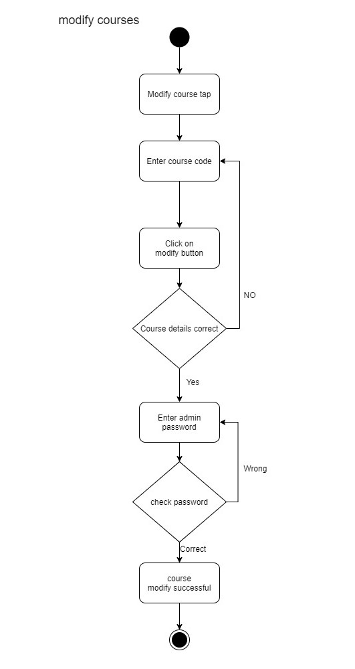

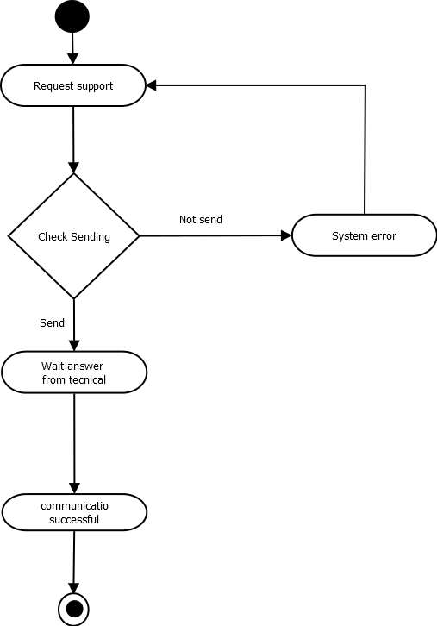

Technical Support

**10-Support**

Chat

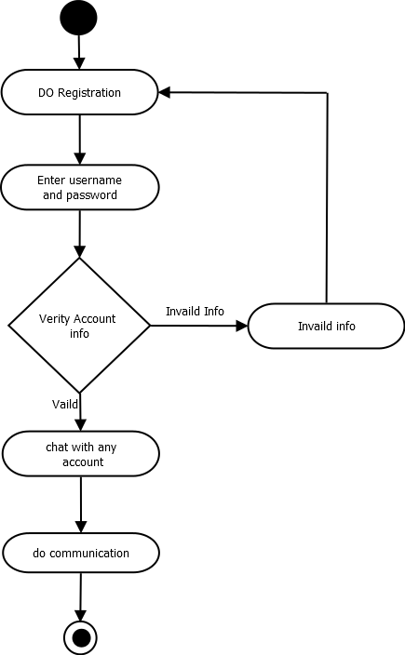

**11-Chat**

12 - progress in courses

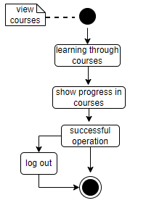

13 - View courses

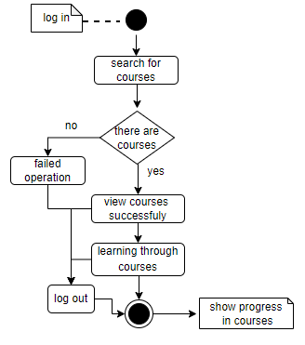

14- View Information:

15- Delete Account

Class Diagram:

Sequence Diagram:

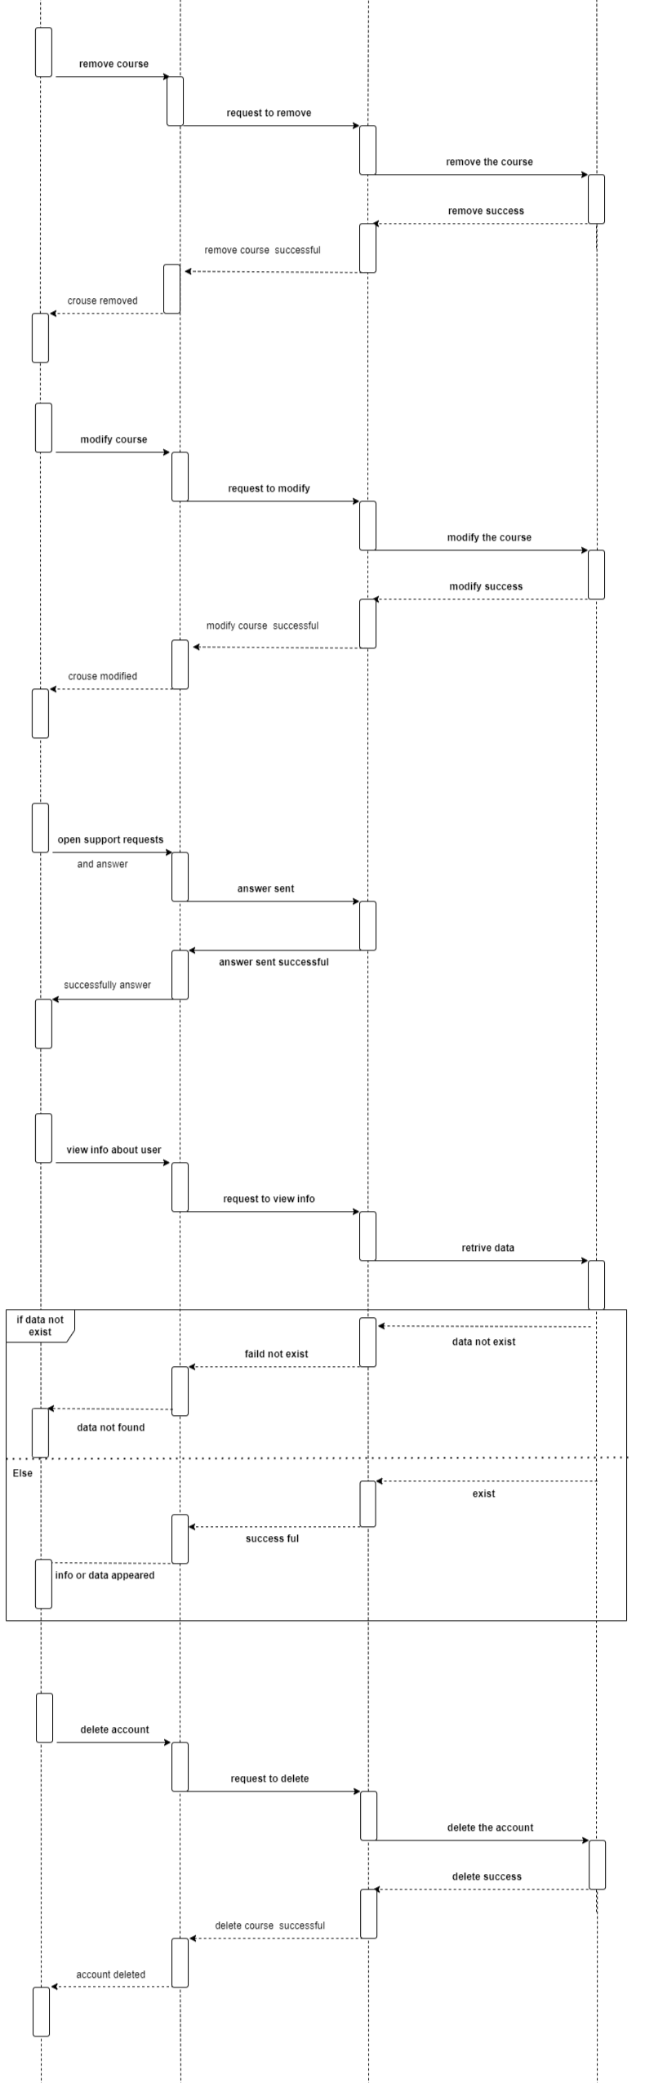

Context Diagram:

Data Flow Diagram:

